Keywords to optimize:
- Why “Employment attorney in Saratoga, CA”

1. Higher-quality search intent
Someone searching "employment attorney Saratoga" or "business litigation attorney Saratoga" is almost certainly a high-net-worth individual or local business owner exactly McLellan's ideal client. Lower volume, but significantly better conversion rate.
2. Almost no competition
Very few firms are actively optimizing for "attorney Saratoga CA." Compare that to "attorney San Jose," where more firms are competing for the same keywords.
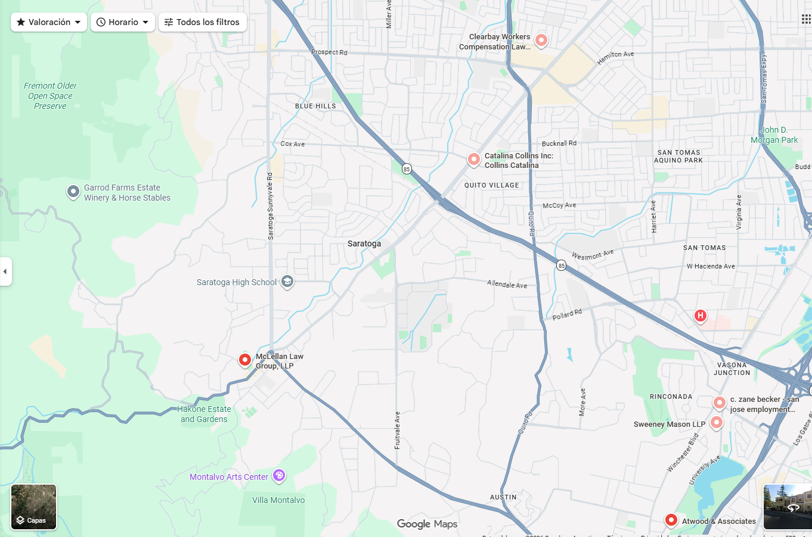

McLellan is the only employment attorney in Saratoga. That's a huge advantage that most firms would kill for.
The risk right now is that if the site isn't optimized for "Saratoga," competitors from San Jose could still outrank them just by having better on-page SEO, even though none of them are actually located there.
3. GMB alignment
The firm's address is in Saratoga, Google prioritizes local results. When someone in Saratoga searches for an attorney, McLellan has a natural proximity advantage.
4. GEO / AI Overviews
When someone asks ChatGPT or Google AI "best employment attorney in Saratoga CA," a site well-optimized for that geo-keyword is far more likely to be cited than a generic Silicon Valley firm.

Page is not optimized for SEO in mobile:

50% of traffic is desktop compared to 26% in mobile, crearly shows a bad experience for mobile.

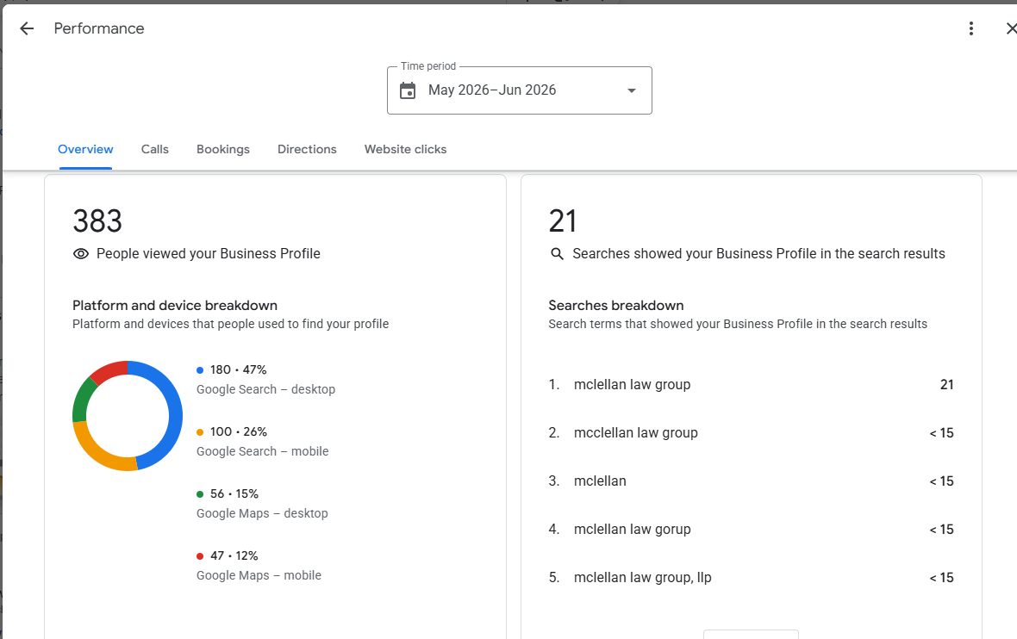

Desktop performance
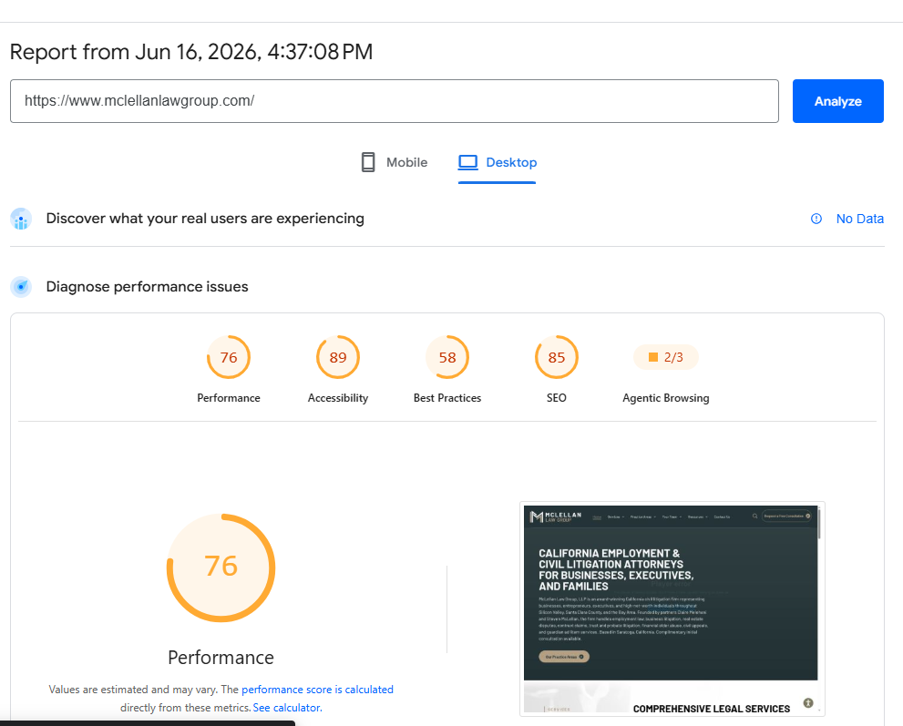

MObile performance
